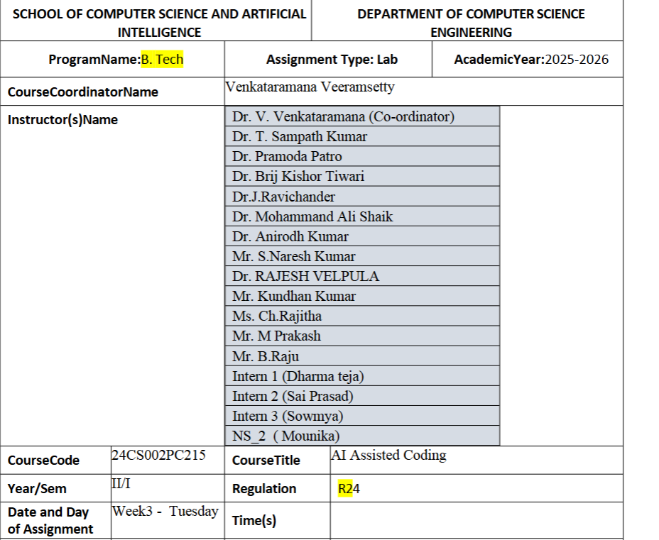
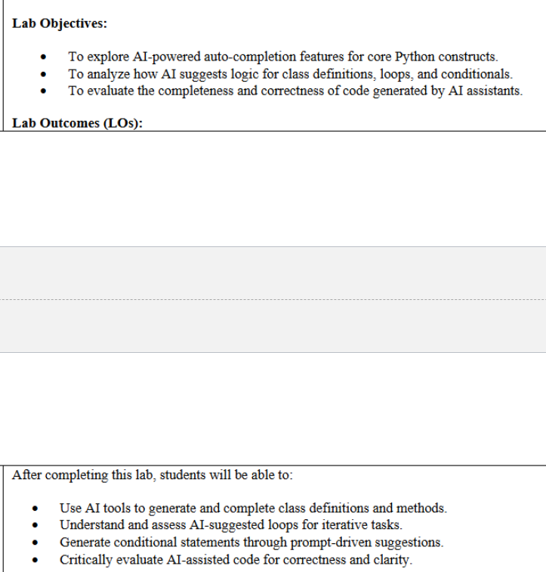
Task Description#1 (Classes)
• Prompt AI to generate a Book class with attributes: title, author, year. Add a method
get_summary() to return a formatted string.
Expected Output#1
• Functional class with constructor and summary method. Students should analyze code
readability and style
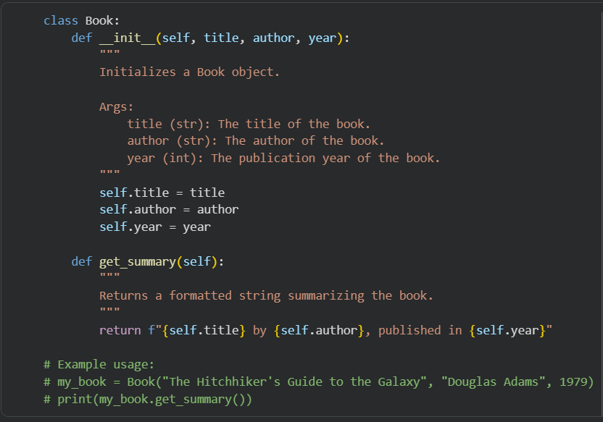
Task Description#2 (Loops)
• Ask AI to generate a function that prints the even numbers between 1 and 50 using a
for loop. Then regenerate using a while loop.
Expected Output#2
• Correct loop-based implementation
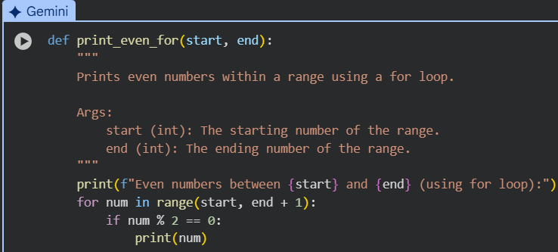
Task Description#3 (Conditional Statements)
• Ask AI to write a function that determines the grade category (A, B, C, Fail) based on
marks using if-elif-else. Then test it with sample inputs.
Expected Output#3
• Function must handle score boundaries and include appropriate logic. Students
analyze boundary cases.
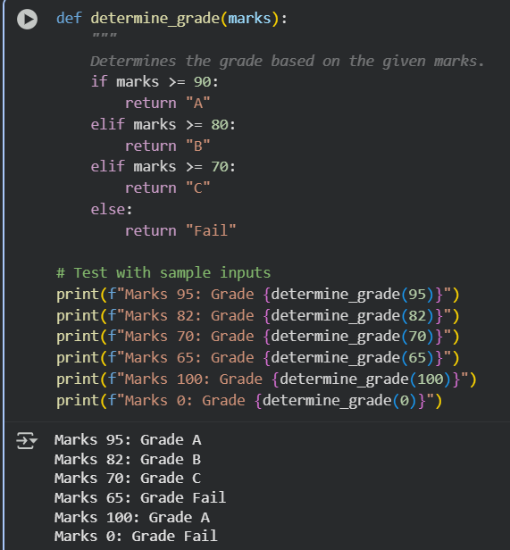
Task Description#4 (For and While loops)
• Generate a function check_eligibility(age, has_id) that checks if a person is eligible to
vote (age ≥ 18 and must have ID). Use nested ifs.
Expected Output#4
• Python code with explanation
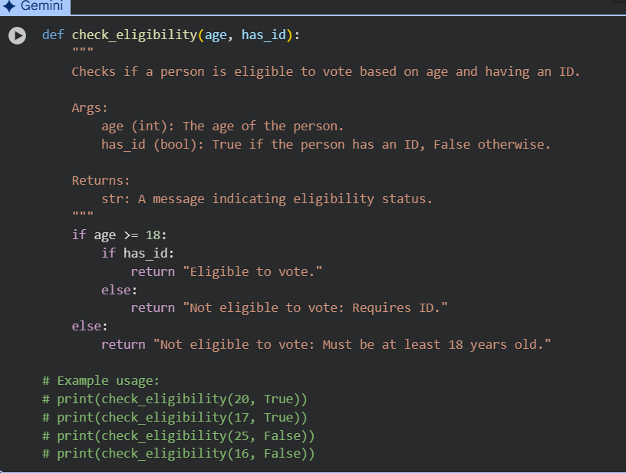
Task Description#5 (Class)
• Ask AI to create a Rectangle class with methods to calculate area() and perimeter().
Expected Output#5
• Python code with explanation
